**Heart attack prediction with Machine learning algorithm:**

Dataset link: <https://www.kaggle.com/rashikrahmanpritom/heart-attack-analysis-prediction-dataset>

About this dataset

* Age : Age of the patient
* Sex : Sex of the patient
* exang: exercise induced angina (1 = yes; 0 = no)
* ca: number of major vessels (0-3)
* cp : Chest Pain type chest pain type
  + Value 1: typical angina
  + Value 2: atypical angina
  + Value 3: non-anginal pain
  + Value 4: asymptomatic
* trtbps : resting blood pressure (in mm Hg)
* chol : cholestoral in mg/dl fetched via BMI sensor
* fbs : (fasting blood sugar > 120 mg/dl) (1 = true; 0 = false)
* rest_ecg : resting electrocardiographic results
  + Value 0: normal
  + Value 1: having ST-T wave abnormality (T wave inversions and/or ST elevation or depression of > 0.05 mV)
  + Value 2: showing probable or definite left ventricular hypertrophy by Estes' criteria
* thalach : maximum heart rate achieved
* target: 0= less chance of heart attack 1= more chance of heart attack

**Dataset Info:**

RangeIndex: 303 entries, 0 to 302

Data columns (total 14 columns):

# Column Non-Null Count Dtype

--- ------ -------------- -----

0 age 303 non-null int64

1 sex 303 non-null int64

2 cp 303 non-null int64

3 trtbps 303 non-null int64

4 chol 303 non-null int64

5 fbs 303 non-null int64

6 restecg 303 non-null int64

7 thalachh 303 non-null int64

8 exng 303 non-null int64

9 oldpeak 303 non-null float64

10 slp 303 non-null int64

11 caa 303 non-null int64

12 thall 303 non-null int64

13 output 303 non-null int64

dtypes: float64(1), int64(13)

**Correlation Heatmap:**

Fig: SNS 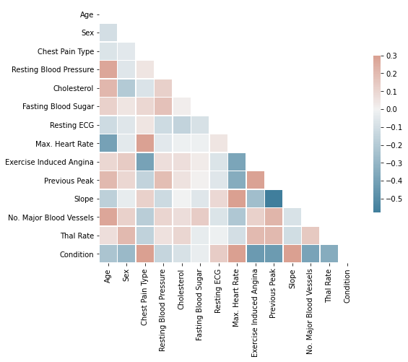

Fig: SNS.Heatmap of correlation.

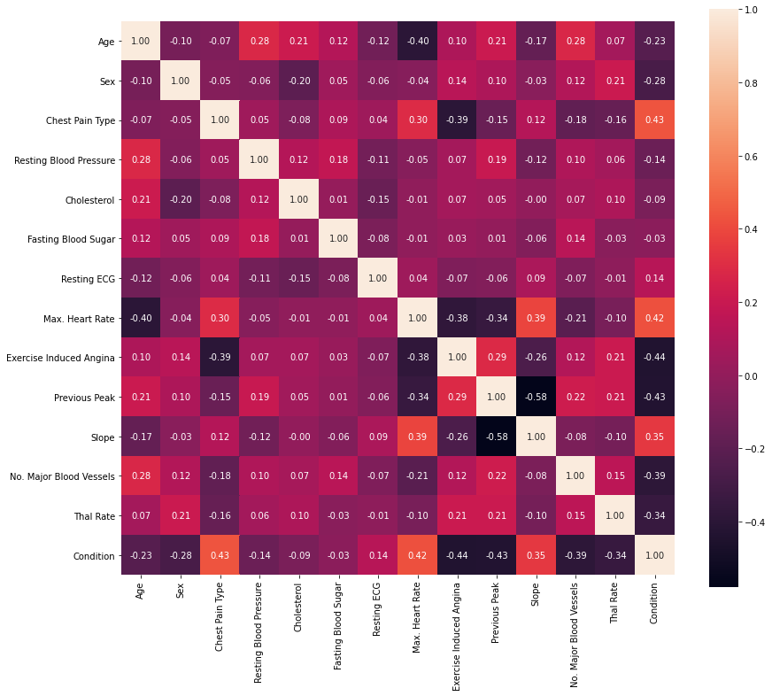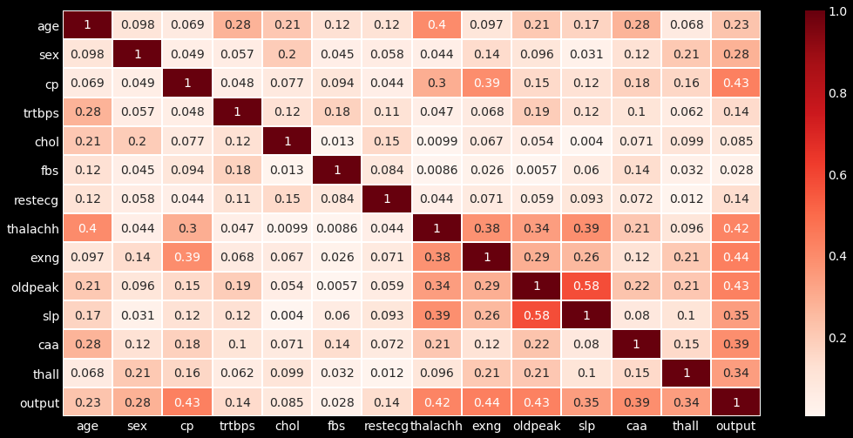

Fig: Correlation Heatmap in two different way.

exng 0.436757

cp 0.433798

oldpeak 0.430696

thalachh 0.421741

caa 0.391724

slp 0.345877

thall 0.344029

sex 0.280937

age 0.225439

trtbps 0.144931

restecg 0.137230

chol 0.085239

fbs 0.028046

**Outliners Present:**

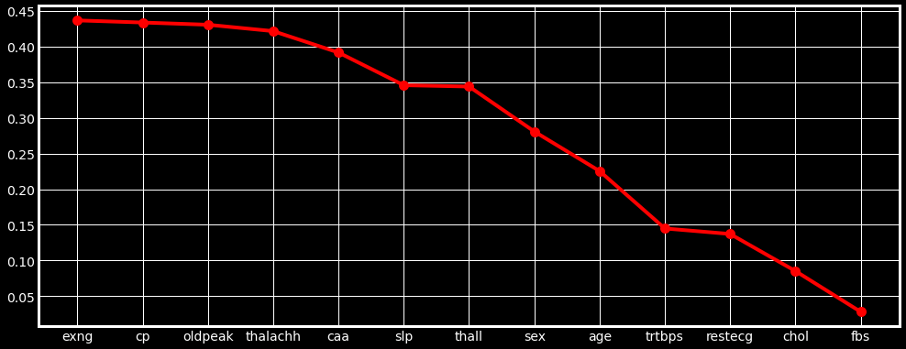

trtbps: (array([ 8, 101, 110, 152, 195, 203, 223, 228, 241, 248, 260, 266, 292]),)

chol: (array([ 28, 85, 96, 220, 246]),)

thalachh: (array([272]),)

oldpeak: (array([101, 204, 221, 250, 291]),)

**Plotting we use:**

**(Black 3D scatter plot)**

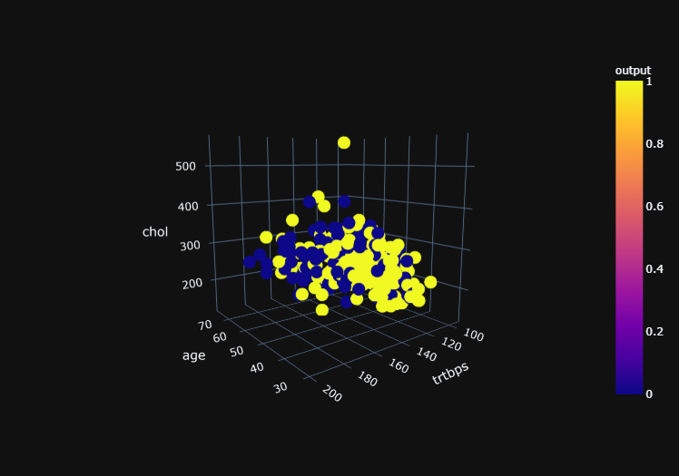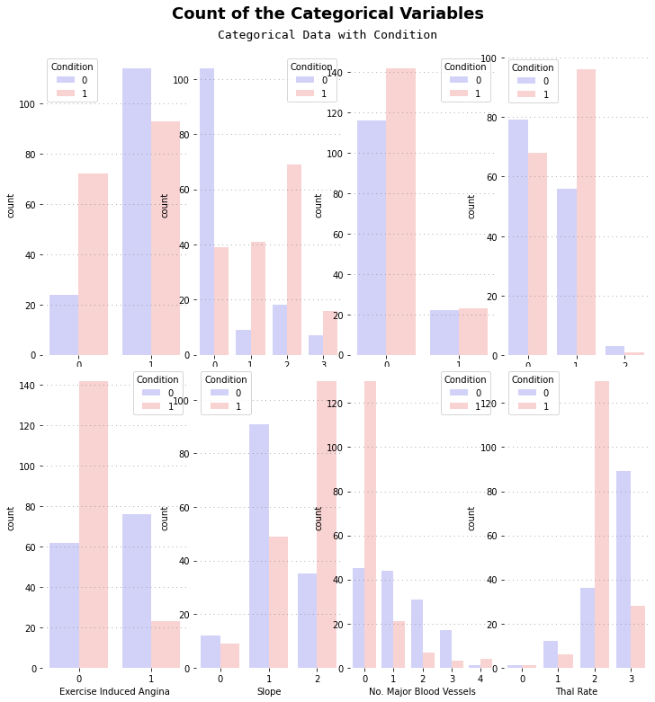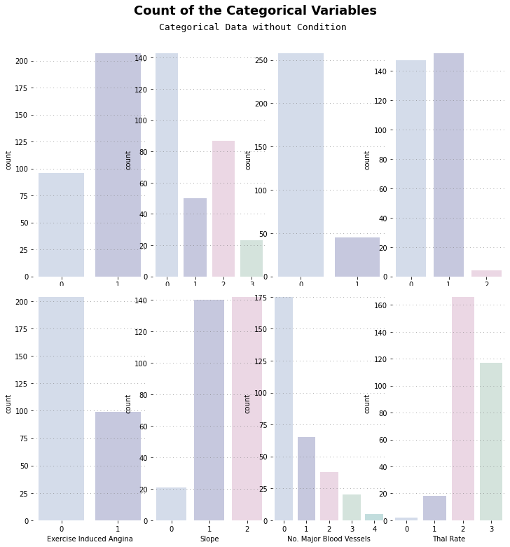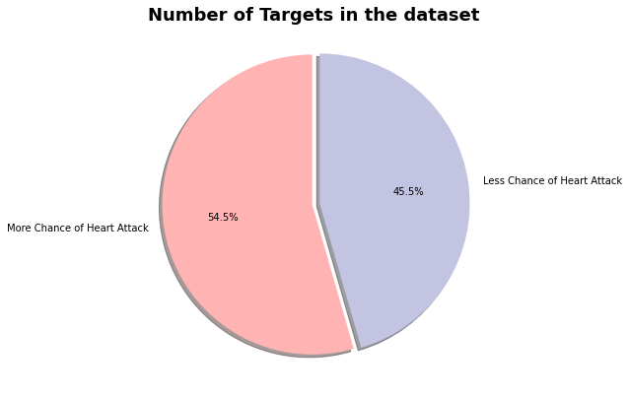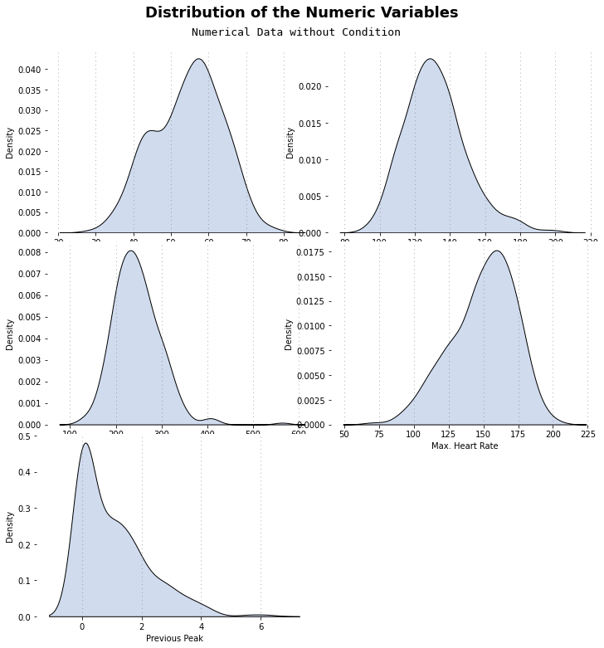

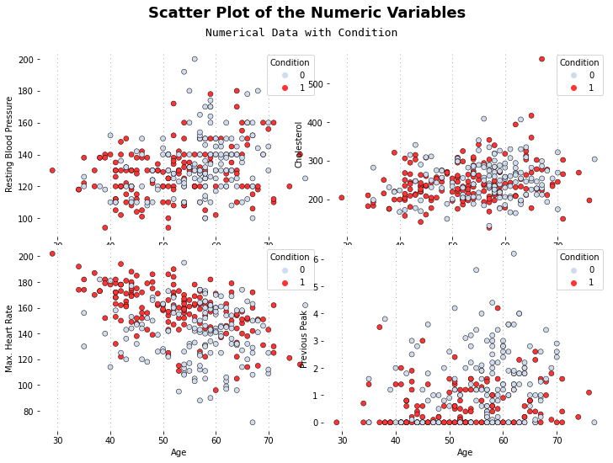

Model we Use:

* XGBoost: 95.08%
* AdaBoost: 93.44%
* MLPClassifier: 93.44%
* Random Forest: 91.8%
* Gradient Boosting: 91.8%
* Logistic Regression: 90.16%
* SVM: 90.16%
* KNN: 88.52%
* Decision Tree: 81.97%

**Logistic regression:**

Execution time of model: 0.01548 seconds

Precision: 0.882

Recall: 0.938

F1-Score: 0.909

Accuracy: 90.164 %

Mean Square Error: 0.098

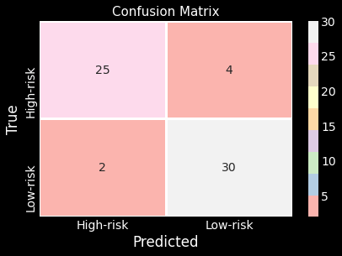

02. K-Nearest-Neighbour:

Execution time of model: 0.00746 seconds

Precision: 0.879

Recall: 0.906

F1-Score: 0.892

Accuracy: 88.525 %

Mean Square Error: 0.115

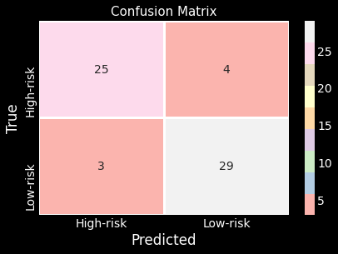

03. Support vector machine:

Execution time of model: 0.00584 seconds

Precision: 0.882

Recall: 0.938

F1-Score: 0.909

Accuracy: 90.164 %

Mean Square Error: 0.098



04. Decision Tree classifier:   
Execution time of model: 0.00371 seconds

Precision: 0.818

Recall: 0.844

F1-Score: 0.831

Accuracy: 81.967 %

Mean Square Error: 0.18

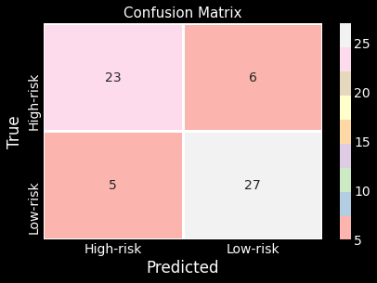

05. Random Forest Classification:

Execution time of model: 0.48786 seconds

Precision: 0.935

Recall: 0.906

F1-Score: 0.921

Accuracy: 91.803 %

Mean Square Error: 0.082

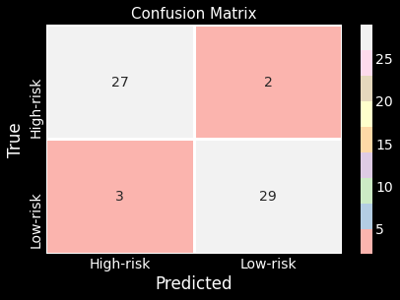

06. Ada boost Classifier:

Execution time of model: 0.04117 seconds

Precision: 0.967

Recall: 0.906

F1-Score: 0.935

Accuracy: 93.443 %

Mean Square Error: 0.066

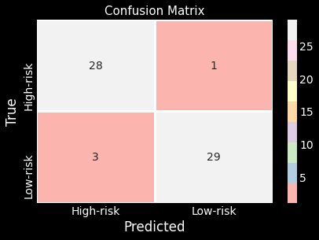

07. Gradient Boosting Classifier:

Execution time of model: 0.02359 seconds

Precision: 0.966

Recall: 0.875

F1-Score: 0.918

Accuracy: 91.803 %

Mean Square Error: 0.082

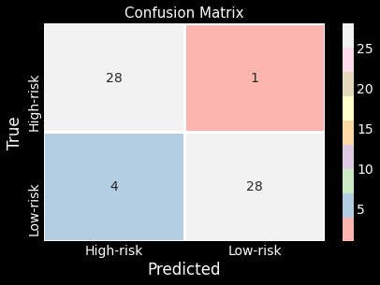

08. XG Boost Classifier:

Execution time of model: 0.01476 seconds

Precision: 0.968

Recall: 0.938

F1-Score: 0.952

Accuracy: 95.082 %

Mean Square Error: 0.049

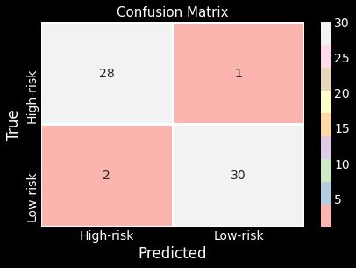

09. MLP classifier:

Execution time of model: 0.96808 seconds

Precision: 0.938

Recall: 0.938

F1-Score: 0.938

Accuracy: 93.443 %

Mean Square Error: 0.066

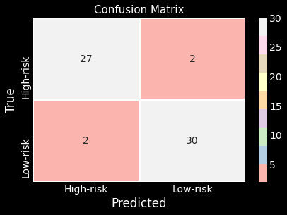

**RMSE Graph and Accuracy graph: (x value 0 to 360)**

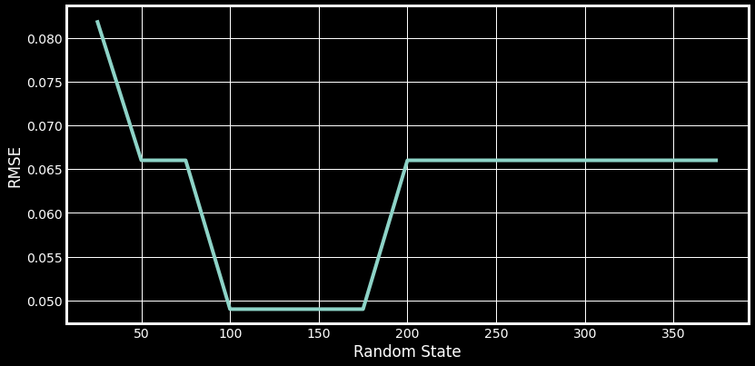

RMSE is lowest at 0.049 for n: [100, 125, 150, 175]

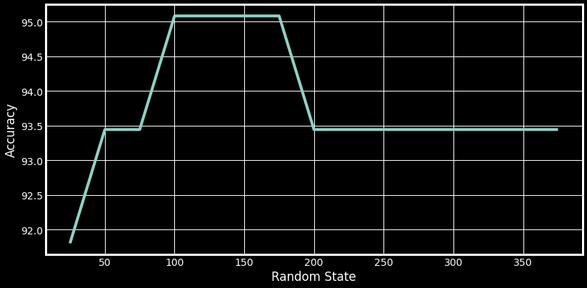

Accuracy is highest at 95.082 % for n: [100, 125, 150, 175]

**Model Performance chart:**

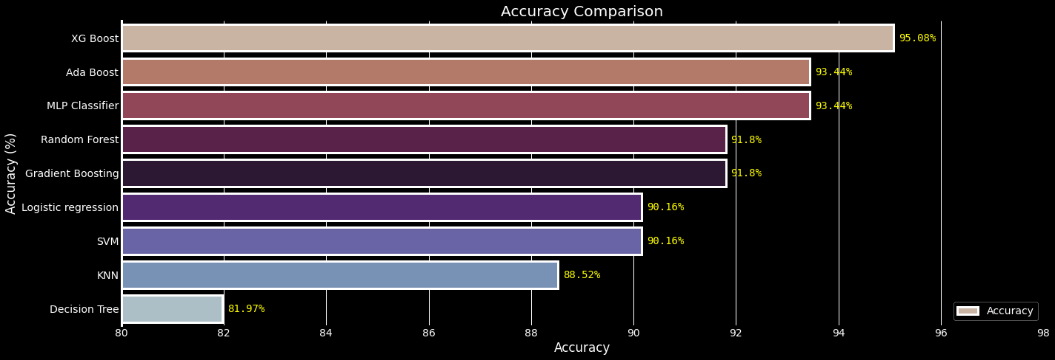

**Model Execution time chart:**

